Create an Authentication Certificate
SharePoint Online moved to requiring certificates for App Only registrations. The certificate needs to be an X.509 Certificate. SEE: Setting up an Entra ID app for app-only access
- This process will use a self-signed X.509 certificate. This is sufficient for applications and you can create one or many per application.

If you want to use a password for the certificate:

powershell -ExecutionPolicy Bypass -File create_spo_app_cert.ps1 -CertSubject "CN=spo-app-only" -ValidYears 2

If you do not want to use a password for the certificate:
powershell -ExecutionPolicy Bypass -File create_spo_app_cert.ps1 -NoPasswordPrompt

Take note of the Thumbprint and remember the password if you used it.

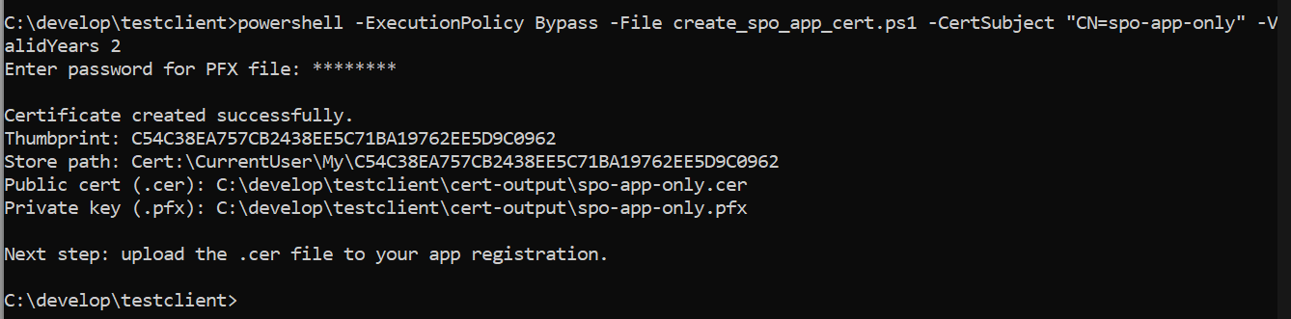
- This will create a cert-output folder that we will need to upload the *.cer file later.

Create An App Registration
- Goto https://portal.azure.com, navigate to your Entra Tenant -> App Registrations
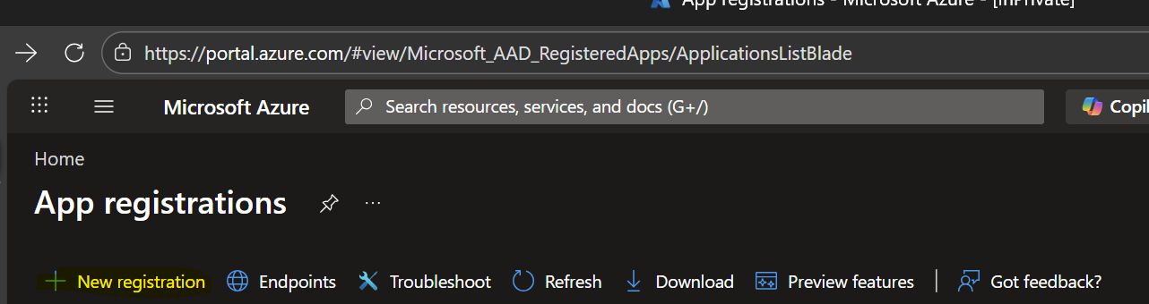
- Fill out the Name, select “Single Tenant Only” might have your org after it, leave Redirect URI blank, hit Register.
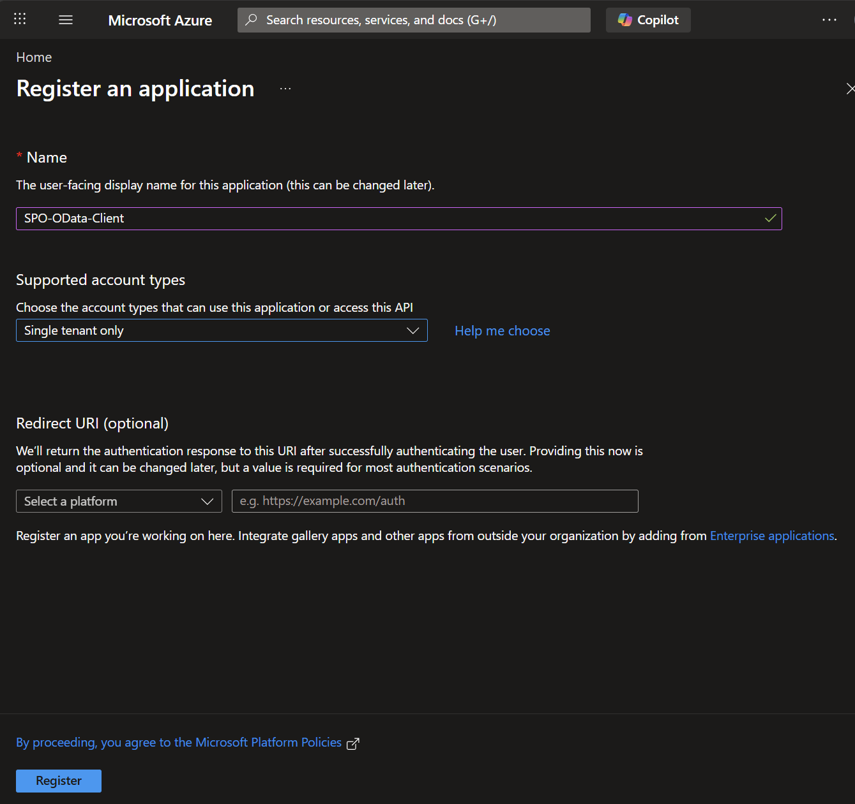
- Once created, it should bring you to the App Registration, if not navigate to App Registration and capture the Application (client) ID and Directory (tenant) ID.
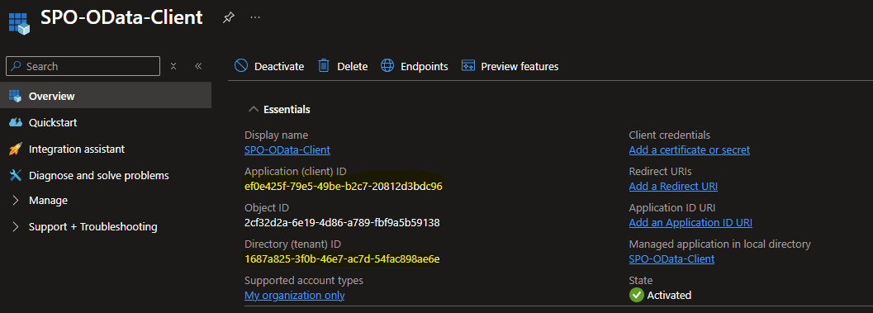
- Drop down the “Manage” menu and go to API Permissions -> Add Permission and locate SharePoint.
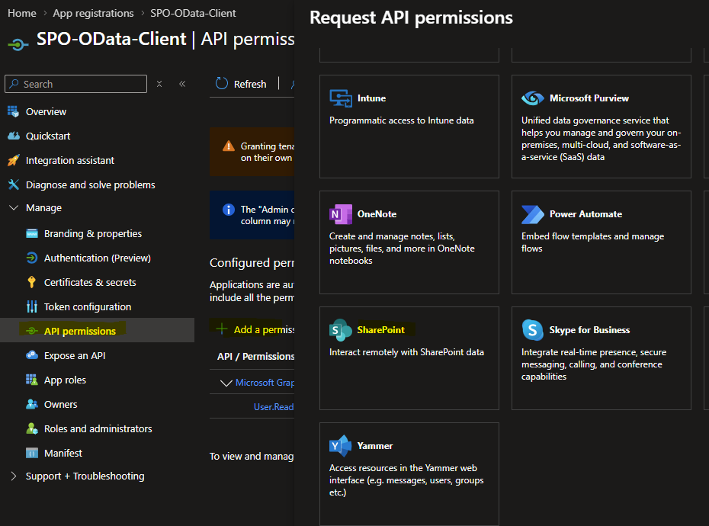

- Select “Application Permissions” and filter by “Sites.”. Once you have the available items, select Sites.FullControl.All, Sites.Read.All, Sites.ReadWrite.All, then hit Add permissions.
NOTE: If you need to add any Graph Permissions, now is the time to do so.
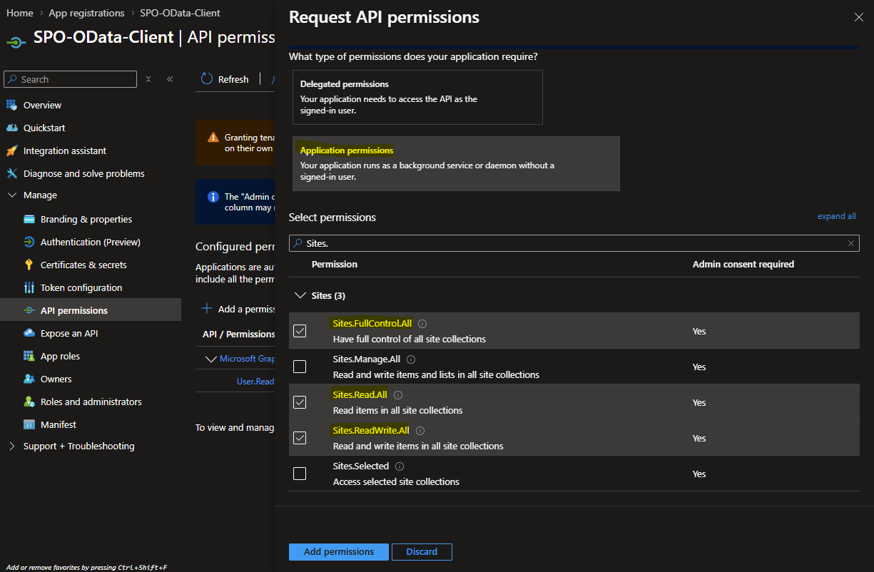
- Once permissions are added, you will see “Not granted for…” since this is for Apps, we need to “Grand admin consent for {tenant}”. Simply click the “Grant admin consent for …” button. Once the confirmation pops up, his “Yes”.
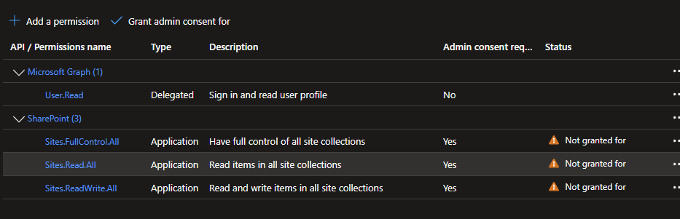
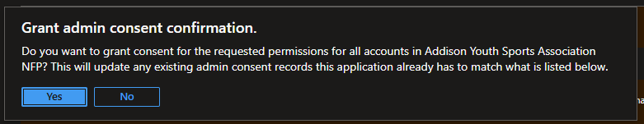
- Upload your certificate, start by navigating to the “Certificates & Secrets” settings. Hit new “Upload Certificate” and select the Certificate generated earlier.
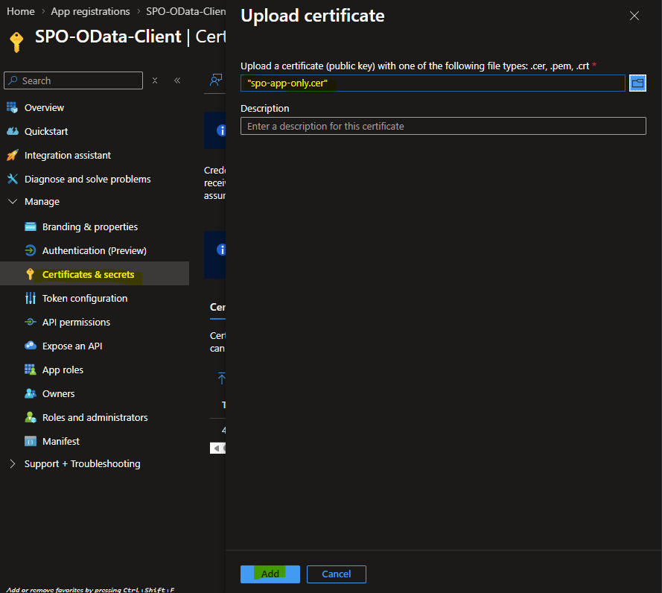

Test your Configuration
- The package includes a python script to test your connection (can be used to sample code/develop). To run the code, open the .env file and set the AZURE_TENANT_ID, AZURE_CLIENT_ID, SHAREPOINT_HOST, SHAREPOINT_SITE_PATH, AZURE_CERT_PFX_PATH and AZURE_CERT_PFX_PASSWORD (if you used one, leave blank if you did not).
- Install python libraries:
python -m pip install -r requirements.txt
- Run the test client
python .\call_spo_odata_web.py

